Check during frontend development

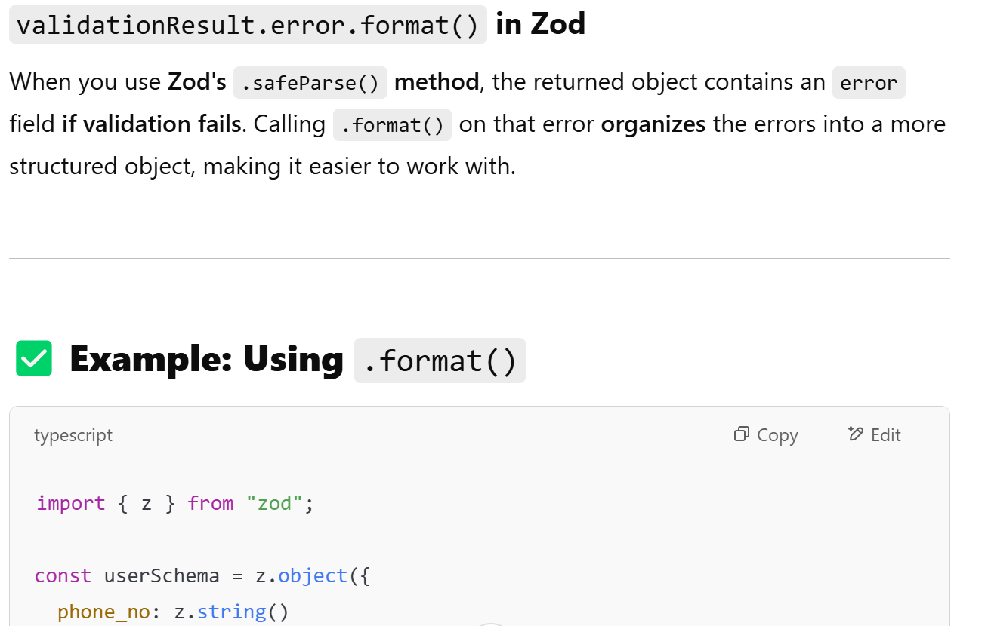

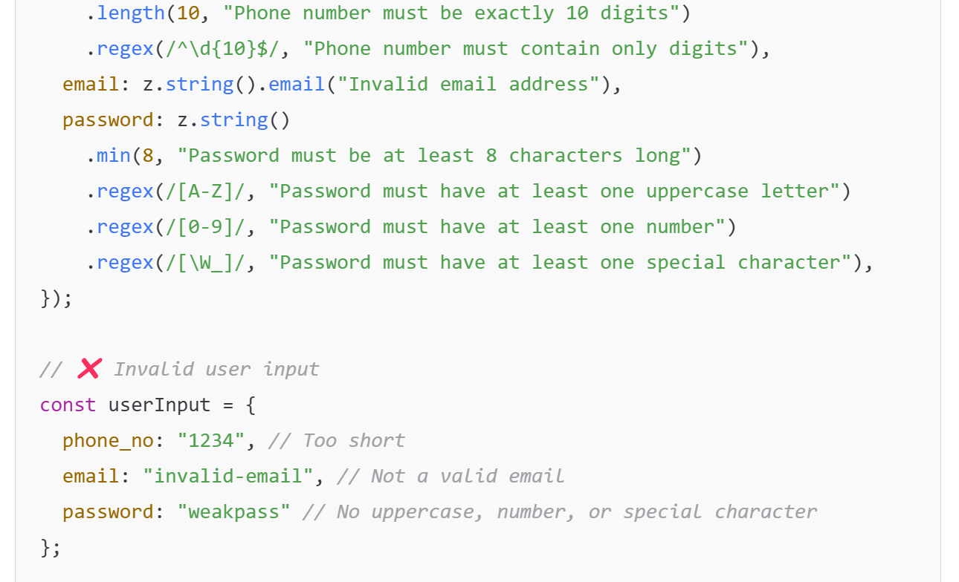

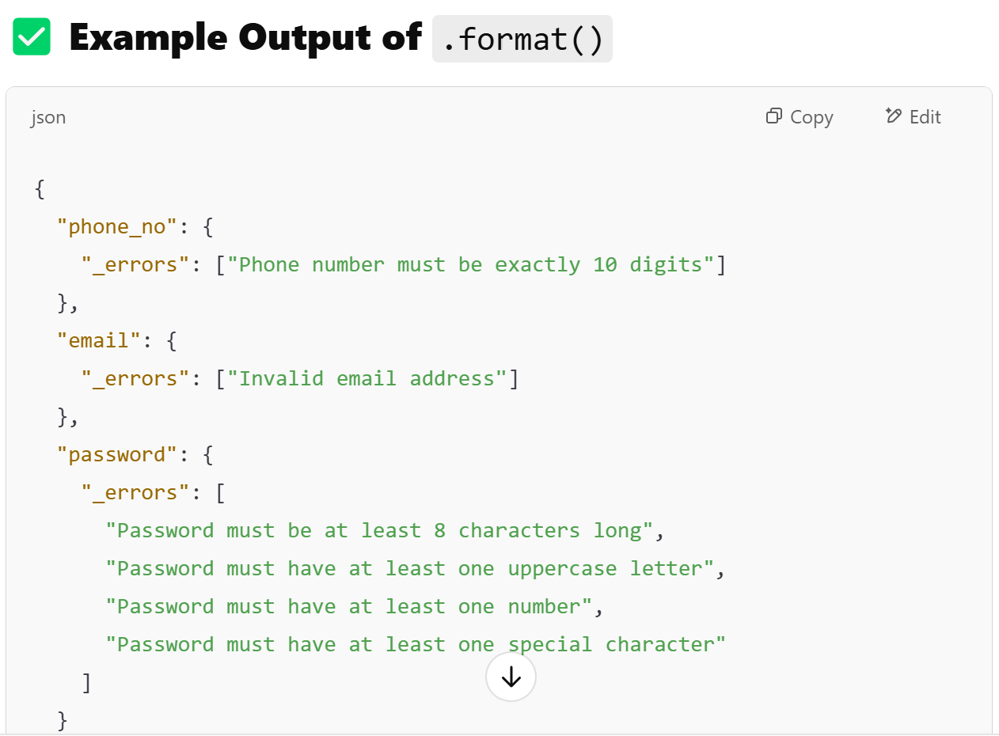

Store accesstoken from login in useState or redux then check if there is accesstoken each time doing api call if no access token call /refresh api for new access token.